Sri Lanka Institute of Information

Technology



Lab Submission

09

**IT24103112**

**Navodya .M.K.N**

B.Sc. (Hons) in Information Technology

(1)



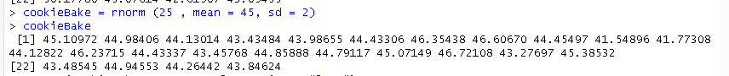

(2)

